Charter
Version 7

March 2025

Acknowledgement
The Queensland Independent Advocacy Network (QIDAN) acknowledges the Traditional Custodians of the place now called Queensland. We pay respect to all Elders past and present and all First Nations people. We recognise their continued connection to the lands and waters, and their ongoing holding of memories, traditions, culture and community aspirations that span more than 65,000 years. We recognise sovereignty has never been ceded and express our sorrow for the personal, spiritual and cultural costs of colonisation and its lasting impacts. It always was and always will be Aboriginal land.
We acknowledge the ongoing impact of colonisationon on people’s lives, now and into the future. Including the ongoing discrimination, violence and human rights abuses on individuals and communities by way of systemic barriers, in policy and practice. We are deeply committed to First Nations people’s self-determination and recognise that by working alongside First Nations disability advocacy organisations and advocates, the disability advocacy sector will continue to create respectful and collaborative partnerships. We learn from the many ways First Nations people shape, challenge, adapt and develop disability advocacy practices. May we walk forward together in harmony and the spirit of healing.
We acknowledge that people’s identities and lives are not segmented, that we have many parts of ourselves. Every day we advocate for people with disabilities who are also First Nations people, or identify as culturally and linguistically diverse, or LGBTIQA+, or living in regional and rural communities.
QIDAN acknowledges the intersectional lived and living experiences of people with disability and their family members, carers and supporters. We respect and honour their resilience and strength in challenging generations of discrimination, coercion and neglect. We recognise the huge contribution people with lived experience make to our work and disability advocacy.

Language
QIDAN believes that language is a powerful tool for building inclusion. We use person-first language by using the term ‘people with disability’ but recognise that many people with disability prefer identity first language (i.e. a disabled person).
Background
The Queensland disability advocacy sector has a long and proud history of working together to achieve positive change for people with disability. In 1986, the Disability Services Act 1986 (Cth) saw the introduction of formal recognition of disability advocacy, advocacy standards and advocacy accreditation. Since then, the disability advocacy sector has worked with people with disability to improve access to services, changes of systems and to uphold individuals’ human rights.
In 1992, the Combined Advocacy Groups of Queensland (CAGQ) was created and advocated for the needs of advocacy organisations and people with disability alike. CAGQ has been integral in ensuring disability advocacy has continued to be funded over the many changes of government.
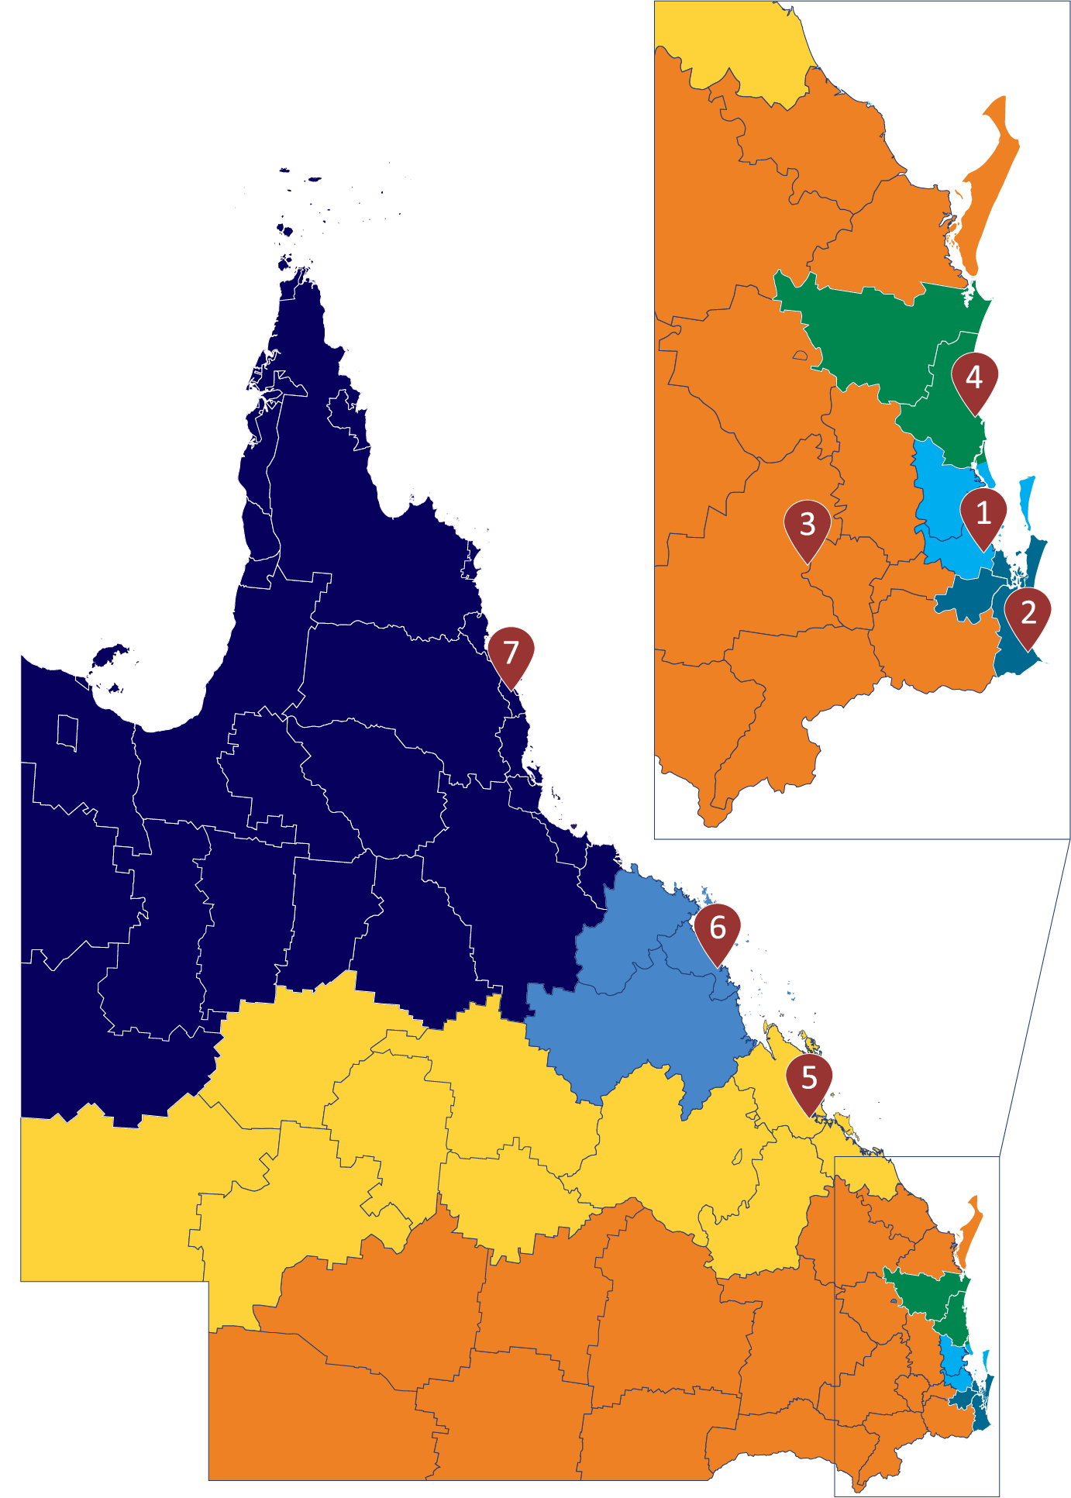
Commencing January 2022, the Qld Department of Families, Seniors, Disability Services and Child Safety (the Department) restructured the delivery of the Queensland Disability Advocacy Program (QDAP). Under this model, independent disability advocacy organisations continue to receive disability advocacy funding to support individuals with disability. Regional disability advocacy funding was continued across the state, with the areas categorised in accordance with Local Government Areas (LGA’s) and National Disability Insurance Scheme (NDIS) service areas. Specialist cohorts programs were funded for First Nations people with disability, people with disability from culturally and linguistically diverse backgrounds and young people with disability. Additionally, funding for a centralised disability advocacy hub (known as Pathways) was made available to support information and referrals to both the specialist individual advocacy organisations and regional individual advocacy organisations.
The advocacy organisations funded under QDAP are in table 1 below.
Queensland Advocacy for Inclusion (QAI) was selected to establish and chair a network consisting of the advocacy organisations to establish the Queensland Independent Disability Advocacy Network (QIDAN).
Regional Individual Advocacy
Organisation | QDAP Region
1. Speaking Up For You (SUFY) | Brisbane – (Brisbane City Council)
1. Speaking Up For You (SUFY) | Caboolture/ Strathpine (Moreton Bay Region)
2. Aged and Disability Advocacy Australia (ADAA) | Beenleigh (Logan City Council & Redland City Council)
2. Aged and Disability Advocacy Australia (ADAA) | Robina (Gold Coast City Council)
3. TASC National Ltd. (TASC) | Bundaberg (Bundaberg Region)
3. TASC National Ltd. (TASC) | Ipswich (Ipswich Council, Lockyer Valley Region, Scenic Rim Region & Somerset Region)
3. TASC National Ltd. (TASC) | Maryborough (Cherbourg Shire, Fraser Coast Region, North Burnett Region & South Burnett Region)
3. TASC National Ltd. (TASC) | Toowoomba (Balonne Shire, Bulloo Shire, Goondiwindi Region, Maranoa Region, Murweh Shire, Paroo Shire, Quilpe Shire, Southern Downs Region, Toowoomba Region & Western Downs Region)
4. People with Disability Australia (PWDA) | Maroochydore (Gympie Region, Noosa Shire & Sunshine Coast Region, Hervey Bay)
5. Capricorn Citizen Advocacy, Vantage Point Program (CCA) | Rockhampton (Banana Shire, Barcaldine Region, Barcoo Shire, Blackall-Tambo Region, Central Highlands Region, Diamantina Shire, Gladstone Region, Livingstone Shire, Longreach Region, Rockhampton Region, Winton Shire & Woorabinda Shire)
6. Mackay Advocacy (MAI) | Mackay (Isaac Region, Mackay Region & Whitsunday Region)
7. Rights in Action (RIA) | Cairns (Aurukun Shire, Cairns Region, Cassowary Coast Region, Cook Shire, Croydon Shire, Douglas Shire, Etheridge Shire, Hope Vale Shire, Kowanyama Shire, Lockhart River Shire, Mapoon Shire, Mareeba Shire, Napranum Shire, Northern Peninsula Area Region, Tablelands Region, Torres Shire, Torres Strait Island Region, Weipa Town, Wujal Wujal Shire & Yarrabah Shire)
7. Rights in Action (RIA) | Townsville (Boulia Shire, Burdekin Shire, Burke Shire, Carpentaria Shire, Charters Towner Region, Cloncurry Shire, Doomadgee Shire, Flinders Shire, Hinchinbrook Shire, McKinlay Shire, Mornington Shire, Mount Isa City Council, Palm Island Shire, Richmond Shire & Townsville City Council)

Specialist Cohort Advocacy – Queensland wide
Organisation | Cohort
Yarn2Action - Aged and Disability Advocacy Australia | Aboriginal and Torres Strait Islander People
AMPARO Advocacy Inc. | Culturally and linguistically diverse people (face-to-face advocacy in Brisbane/ Moreton Bay or phone advocacy or support to connect with local advocacy agency elsewhere in Queensland)
Queensland Advocacy for Inclusion, Young Peoples Program (QAI) | Young people (under 18)

Information and Referral – Queensland wide
Organisation | Program
Queensland Advocacy for Inclusion (QAI) | Pathways
Purpose
The Queensland Independent Disability Advocacy Network (QIDAN) is a network of independent disability advocacy organisations in Queensland. QIDAN protects and promotes independent advocacy to uphold the rights, interests, and wellbeing of people with disability, ensuring socially just, accessible, and inclusive communities.
Aims
Systemic advocacy: to take coordinated action to address systemic issues experienced by people with disability,
Member support: to provide a collaborative space for the exchange of issues, solutions, information and resources affecting disability advocacy organisations, and
Sector advocacy: to promote the importance and value of independent disability advocacy on a local, state and national basis.
Principles
QIDAN’s principles are underpinned by the United Nations Convention on the Rights of Persons with Disabilities (UNCRPD). QIDAN’s work will support the progressive implementation of the UNCRPD and recognise the importance of involving people with disability in all aspects of decision making and governance. QIDAN recognises that despite instruments such as the UNCRPD, people with disability continue to face additional and complex barriers in equal participation as members of society and will continue to advocate for meaningful and equitable inclusion.
QIDAN principles, include being:
- Guided by people with disability and human rights principles
- Independent from service provision and Government
- Committed to First Nation’s people’s self-determination and sovereignty, by creating respectful and collaborative partnerships across the disability advocacy sector with First Nation’s Elders, organisations, programs and community members
- Creating opportunities for people with disability to have agency in decision making
- Acting with integrity and accountability
- Committed to developing our capacity to lead and strengthen the disability advocacy sector through collaboration and collective action and quality data
- Committed to intersectionality in our individual and system advocacy
- Committed to responding to and addressing the additional barriers that are experienced by First Nations people, people from culturally and linguistically diverse background, LGBTIQA+ people living with disability, people living in rural and remote locations and people in closed environments. This includes ensuring our practice is culturally safer and responsive to individual needs.
QIDAN will ensure that when completing its work, that it will maintain standards in line with the National Standards for Disability Services and Human Services Quality Framework.
Disability Advocacy
Independent advocacy for people with disability is working alongside people facing disadvantage to promote, protect, and defend human rights, interests, and wellbeing.
Independent advocates do this by:
- Being person led and supporting will and preference
- Being partisan, remaining loyal and accountable
- Being professional, culturally safe, and vigorous in pursuit of fundamental needs, and
- Avoiding conflicts of interest.
Membership
QIDAN has a core membership of organisations that are funded under QDAP. Core members have full voting rights. These organisations are included in table 1.
All QIDAN members are Disabled People’s Organisations (DPO), meaning they are controlled by people with disability (at least 51% people with disability at the board and membership levels).
QIDAN also has the option for Queensland based National Disability Advocacy Program (NDAP) providers to apply or be invited to join QIDAN as an associate membership. Associate membership does not provide voting rights, rather it, provides an opportunity for organisations to raise systemic issues and to collaborate with QIDAN. The organisation must align with QIDAN’s Charter and Core members make the final decision on whether an organisation can be an associate member. This ensures organisations joining QIDAN are aligned to the Charter and undertake related and complementary work. QIDAN will annually review associate membership.
QIDAN will collaborate with organisations on matters the core membership group deems appropriate. QIDAN will also seek endorsement of submissions and campaigns where relevant.
Role of the Chair
The role of the Chair continues to develop with the network and advocates professional needs. Some of the ways QAI chairs the network includes:
- Preparing fortnightly email updates with sector news, opportunities, key dates and reports relevant to QIDAN members.
- Maintaining the QIDAN TEAMS channel to store relevant documentation (such as minutes, submissions, operational documentation), allow collaboration, and contribute to advocacy activities, share resources etc.
- Draft, maintain and review operational documents for QIDAN including the Charter, Data Manual, decision-making records, and records of expenditure.
- Facilitating monthly QIDAN meetings held via Microsoft TEAMS, including setting agendas, taking minutes, inviting guests.
- Plan, host, and facilitate in-person meetings of the network as resourcing allows. QIDAN will aim to meet at least once per year in person.
- Plan, host, and facilitate capacity building activities such as the disability advocacy conference, and Community of Practice online sessions.
- Represent the collective voices of members in advocacy campaigns.
- Plan, research, consult and prepare systemic advocacy advice on behalf of QIDAN.
- Plan and facilitate meetings between QIDAN and external stakeholders such as the Minister for Disability Services, the Department of Disability Services, the Office of the Public Guardian, and the National Disability Insurance Agency.
- Collate reporting from QDAP funded organsiations to analyse data for funding submissions, sector and systemic advocacy.
- Ensure decision making processes are followed.
Role of Member Organisations
- Represent QIDAN at community forums and events for example with a QIDAN badge/ banner at in person events, QIDAN email signature, link to QIDAN website.
- Attend QIDAN monthly meetings and in-person meetings to provide updates, contribute to discussion and represent the organisations views.
- Provide input into QIDAN operational documents, sector and systemic advocacy within agreed timeframes.
- Update the Chair monthly with organisational capacity, new staff and issues impacting referrals.
- Provide the Chair with a copy of QDAP reporting consistent with the QIDAN data manual
- Consider opportunities to host specific events, discussions, working groups, or consultations for matters that organisations are passionate about or have specialist knowledge in.
- Chair or facilitate specific online or face-to-face QIDAN program components e.g. CoP sessions, subject matter expert sessions.
- Provide a response to referrals made by other QIDAN organisations for disability advocacy.
Decision-Making
All QIDAN members are independent entities and operate independently outside of QIDAN and as a result, each has their own operating procedures for decision making/ positions taken. During meetings (both virtually and in person) all individual advocates will be encouraged to respectfully voice their position on matters.
Unanimity (full agreement) on all decisions involving QIDAN organisations will be for the aim during these meetings. However, should that be unachievable, then consensus (when no one disagrees) will be the default decision making mode. Failing that, the majority view of members will be adopted. Should an organisation strongly disagree with the majority view taken, they will have the option to have their view recorded in the meeting minutes, and they can optout of being a signatory on any relevant systemic work.
It is acknowledged that not all matters will be able to be decided during meetings. Should an organisation require further time to decide their position, when time permits, the organisation will have 5 (five) business days after the meeting to provide written notice of the organisation’s position to the Chair. The general unavailability of core network members during holiday periods or other disruptions to normal business flow will also be considered where possible.
As QIDAN operates as a network, a decision-making spreadsheet will be held by the Chair to ensure there is a recording of decisions made. Where members contribute funds for agreed purposes, a record of expenditure will be kept by the Chair.
Managing Conflicts of Interest
All members must always act in the interests of the advocacy organisation they are representing.
QIDAN members are independent from Government and NDIS Service provision and do not provide supports under the NDIS.
A conflict of interest can be actual, potential or perceived and may occur where the direct or indirect personal interests of a QIDAN member conflict with, are in opposition to appear to or inappropriately influence how they make decisions or perform their roles. If a potential, perceived or actual conflict of interests is identified before or during a meeting that may be relevant to an issue under consideration, the member may be asked to:
- Contribute to the discussion but abstain from voting or taking part in a decision on the matter,
- Observe but not take part in the discussion or decision making,
- Ask another person from the member organsiation to attend the meeting to represent the member organisation,
- Leave the meeting during discussion and decision on the matter, or
- Any combination of the above.
Where there is a significant and ongoing conflict of interest, individuals may be asked to leave the network and ask another person from the organisation to be the QIDAN representative or, propose a strategy for managing the conflict of interest on an ongoing basis.
Prioritising Systemic Advocacy
We advocate for long-term and sustainable changes to barriers experienced by people with disability. This involves pushing for inclusive services, systems, legislation, and policies that create lasting change and support.
We do this by:
- Engaging with advocates across the network
- Analysing data
- Writing submissions and reports
- Working on campaigns
QIDAN’s approach to systemic advocacy is driven by the experiences, identified gaps and concerns raised by independent disability advocates in collaboration with people with disability. Our priorities are based on people’s fundamental needs and are viewed through a cultural, social justice, and human rights framework.
The common barriers experienced by people with disability include:
- Attitudinal and cultural barriers (such as stereotypes, stigma, prejudice, and discrimination)
- Social barriers (such an underemployment, access to healthcare, access to education, and experiencing violence)
- Accessibility barriers (such as inaccessible environments or communication)
- Policy barriers (such as being denied access to programs, services, or opportunities to participate)
- Systemic barriers (such as systems / structures that treat people with disability unfairly, or legislation failing to properly address the needs of people with disability).
QIDAN is committed to addressing the additional barriers experienced by Aboriginal and Torres Strait Islander people, people from culturally and linguistically diverse backgrounds, LGBTIQA+ people, those in rural and remote locations, and closed environments in all our systemic advocacy efforts. QIDAN focuses on human rights, supported decision making and de-institutionalisation in all systemic advocacy work.
The priorities for QIDAN are shaped by a variety of factors that will continue to evolve. As a result, QIDAN remains flexible, adaptable and responsive to the needs of member organisations and people with disabilities.
QIDAN’s advice is informed by:
- the insights gained from delivering individual advocacy,
- analysing QIDAN’s reporting data, and
- evaluating what can be achieved collectively at any given time.
To guide this process QIDAN, though the Chair of QAI, has developed a systemic advocacy decision-making matrix to assess ongoing advocacy efforts and inform priorities. The System Advocates at QAI, the Chair of QIDAN, make these decisions in collaboration with QIDAN.
Identified issues, upcoming systemic advocacy and outcomes of systemic advocacy will be a standing agenda item for QIDAN monthly meetings for the systems advocates to provide updates on.
Review
The QIDAN Charter will be reviewed in 2028, or earlier if required.

